
SCHOOL OF COMPUTING AND ENGINEERING SCIENCES (SCES)
BACHELOR OF SCIENCE IN ELECTRICAL AND ELECTRONICS ENGINEERING (BSEEE)
CIRCUIT THEORY EXPERIMENT ON BLINKING LED
BY:
Mwongela Edward Aribu - 142092
COLLABORATORS:
Shanice Mwenda Kendi - 145709
Abigail Wangechi Ndegwa – 145527

ABSTRACT
This is a report that contains the data obtained in a laboratory experiment conducted in the Strathmore engineering laboratories by the group 11 members 11TH of February 2022. It covers DC current blinking LED experiment
Table of Contents
ABSTRACT 2
INTRODUCTION 4
Table of contents 5
OBJECTIVES AND EXPECTED OUTCOMES 6
CIRCUIT DIAGRAMS, THEORETICAL ANALYSES, SAMPLE CALCULATIONS AND SIMULATIONS 7
MATERIALS, APPARATUS, METHODOLOGY AND TABLES 11
Apparatus 11
PROCEDURE 11
EXPERIMENTAL SETUP, RESULTS AND GRAPHS 12
VIDEO UPLOAD 14
REFERENCES 15

INTRODUCTION
Direct current is defined by the constant flow of electrons (see figure 1) from an area of high electron density to an area of low electron density. In circuits involving batteries, this is illustrated by the constant flow of charge from the negative terminal of the battery to the positive terminal of the battery. It is much more expensive and difficult to change the voltage of direct current as opposed to alternating current, making it a poor choice for the high voltage transmission of electricity. However, for very long distances, HVDC transmission can be more efficient than alternating current.(Direct Current - Energy Education, n.d.)

Table of contents
Figure 1 7
Figure 2 7
Figure 3 8
Figure 4 8
Figure 5 9
Figure 6 9
Figure 7 10
Figure 8 12

OBJECTIVES AND EXPECTED OUTCOMES

CIRCUIT DIAGRAMS, THEORETICAL ANALYSES, SAMPLE CALCULATIONS AND SIMULATIONS

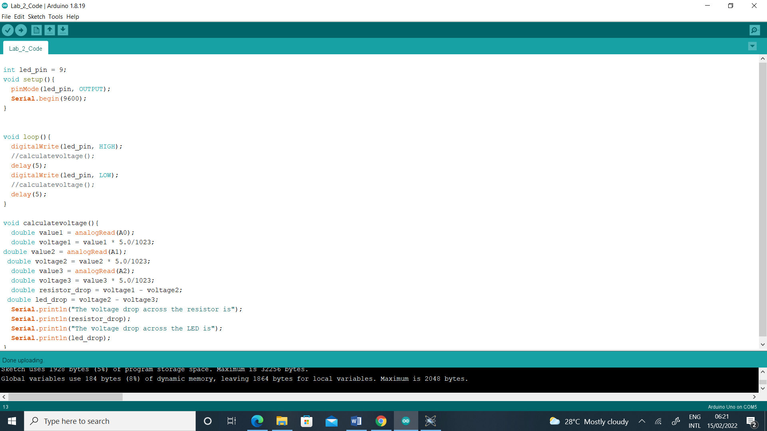
Figure 1
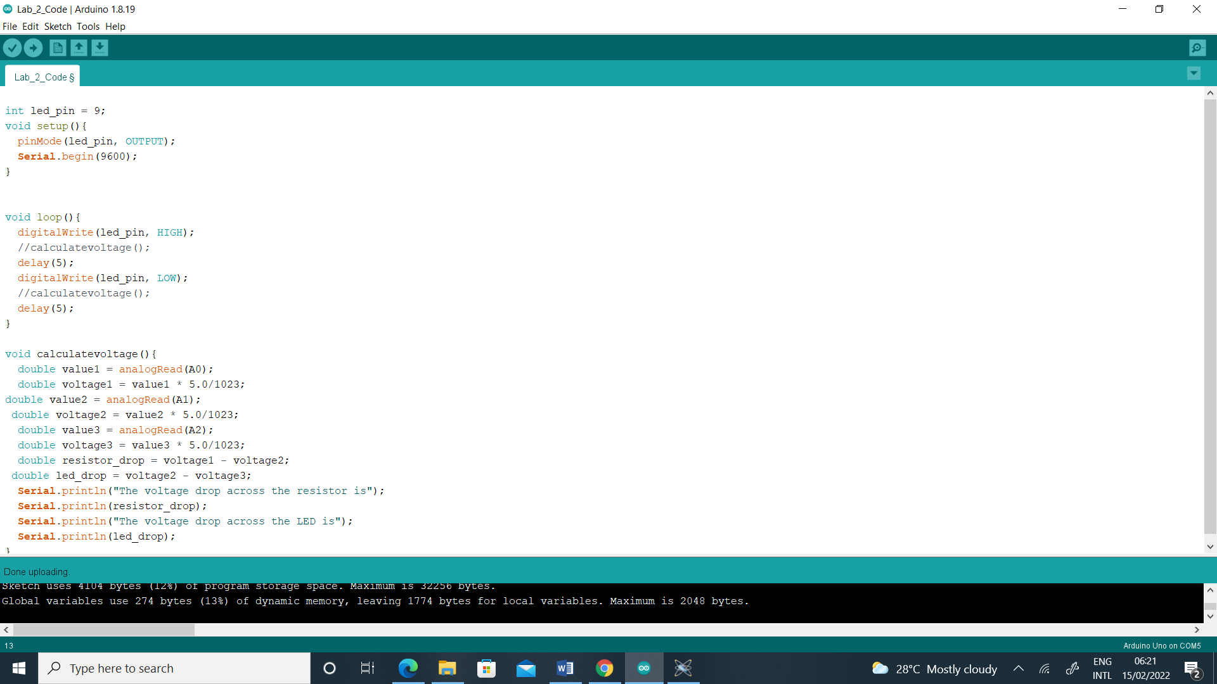
Figure 2
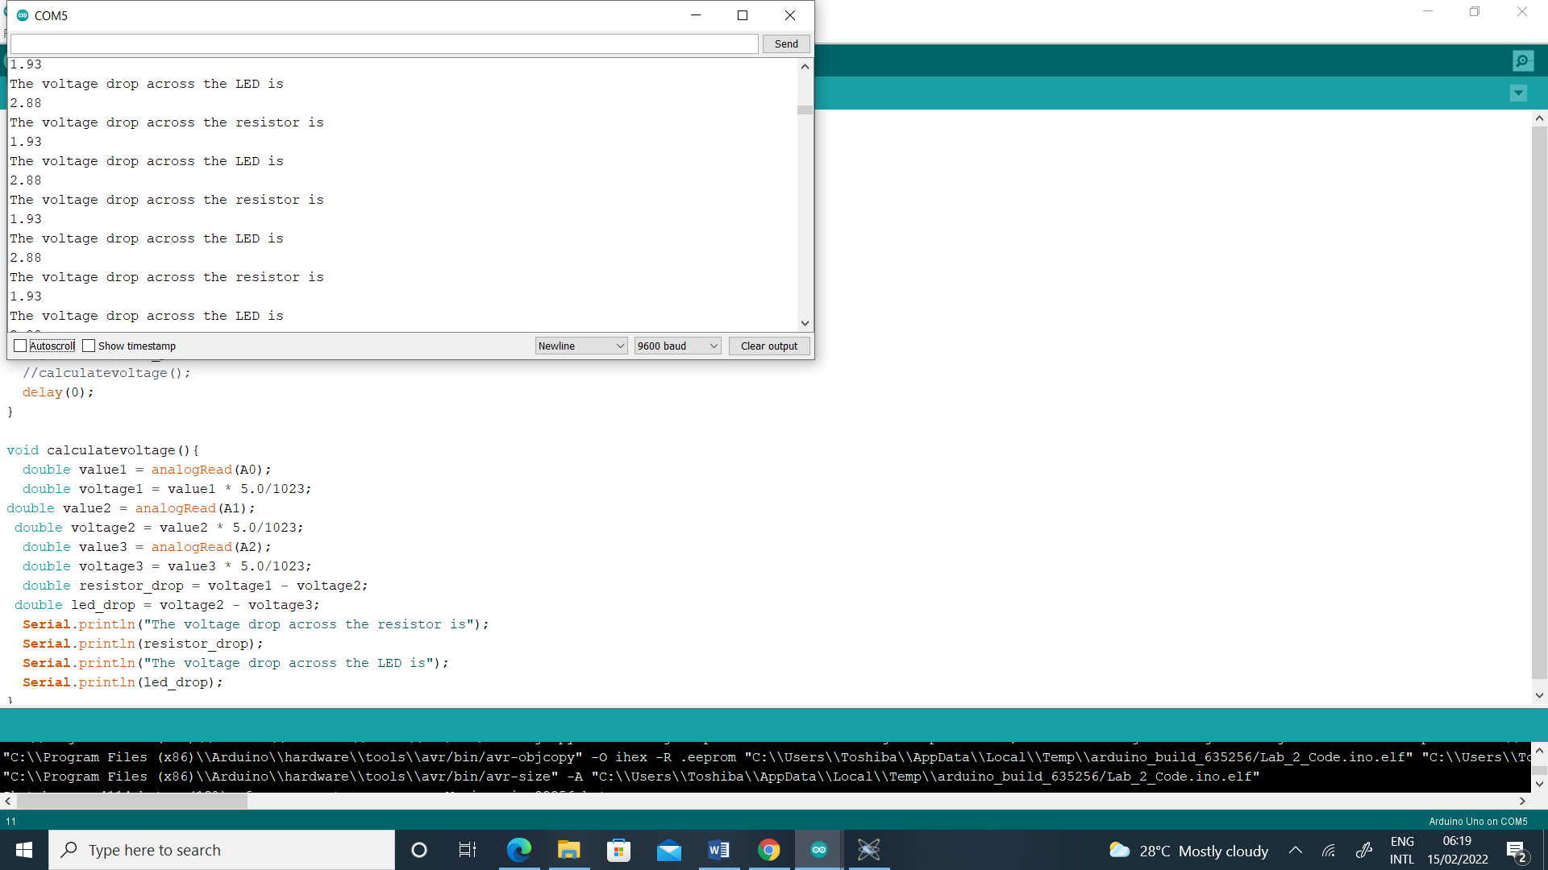
Figure 3
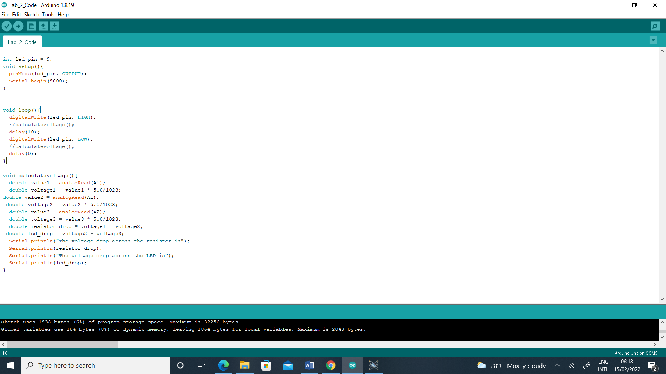
Figure 4
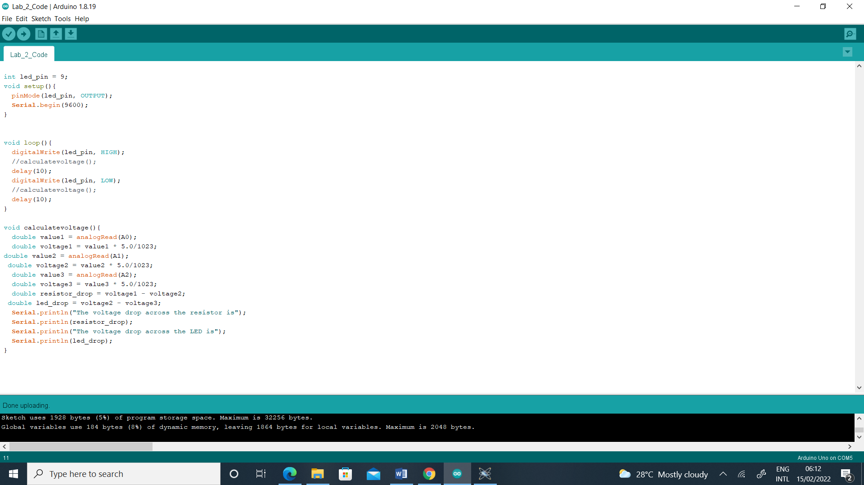
Figure 5
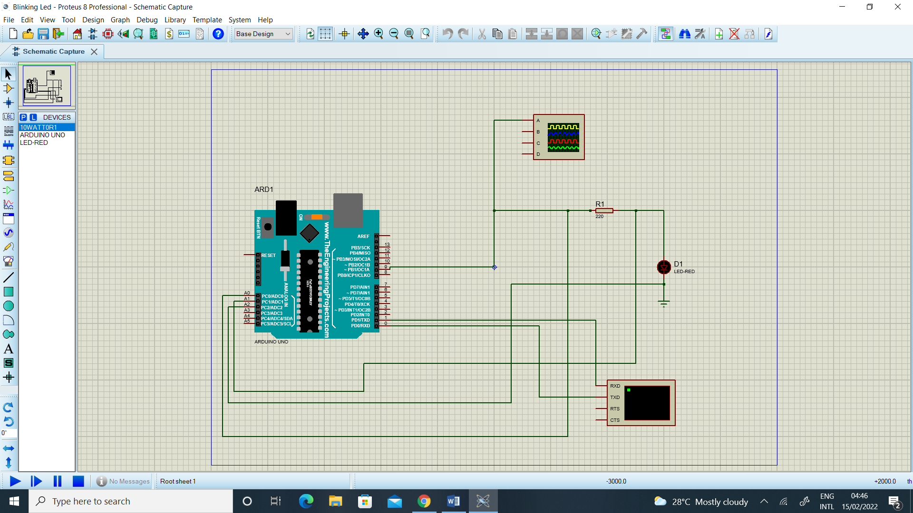
Figure 6
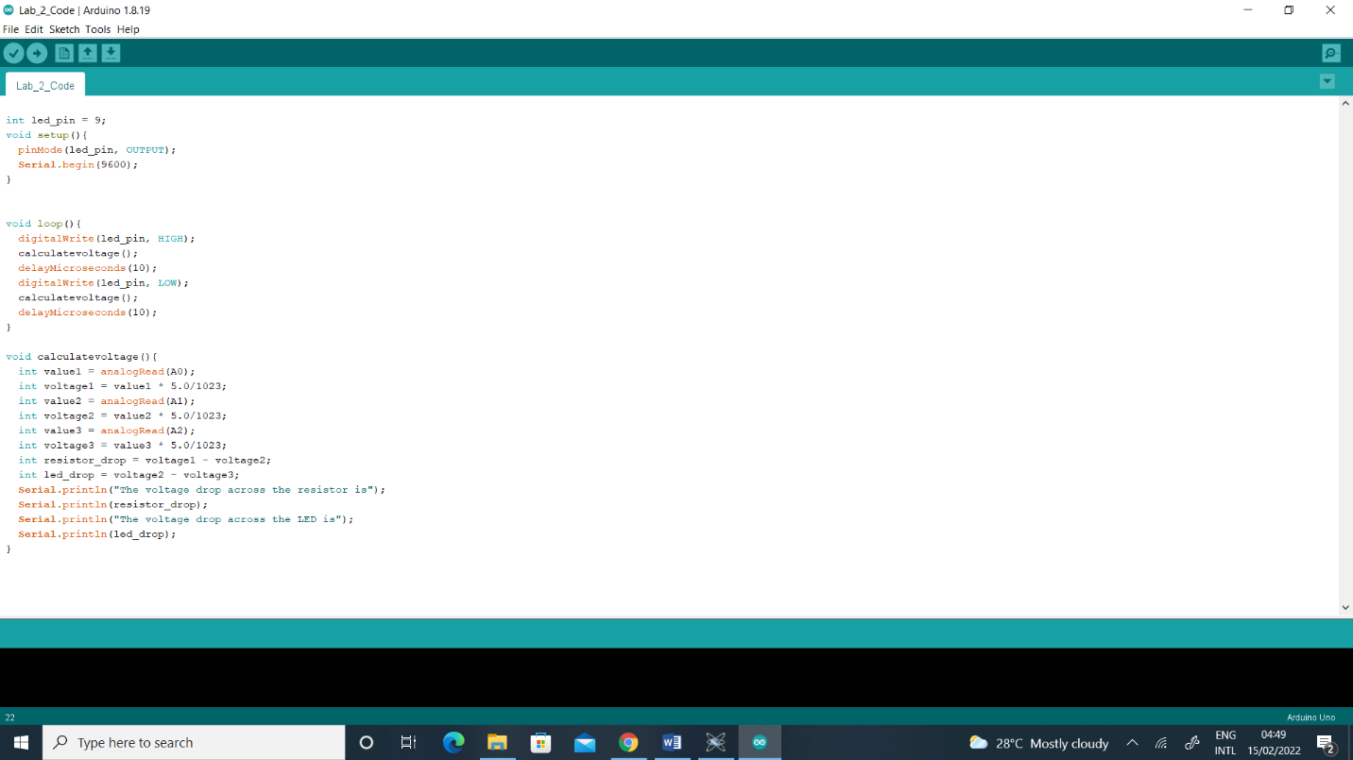
Figure 7

MATERIALS, APPARATUS, METHODOLOGY AND TABLES

Apparatus
1. One Led
2. 5-Jumping wires
3. 220 -ohm resistor
4. Arduino Uno
5. Breadboard

PROCEDURE
1. Choose appropriate circuit elements, draw the circuit that can drive a single LED powered from the output pin of an Arduino Uno, simulate, and measure the power consumed by the LED.
2. Draw a schematic for sampling the LED voltage and the resistor voltage using the ADCs provided on the Arduino Uno, write code to calculate the power consumed by the LED and compare the results with 1 above assuming a fixed 5V DC voltage.
3. Use simulation to obtain a suitable PWM scheme to vary the on/off times of the LED, record the power consumed by the LED. Use the following PWM schemes (1ms rise time, 1ms fall time, PERIOD 10ms, on/off times 10ms/0ms, 5ms/5ms, PERIOD 100ms, on/off times 100ms/0ms, 50ms/50ms, PERIOD 2 seconds on/off times 2s/0s, 1s/1s.
4. Program the Arduino Uno to obtain the PWM scheme to vary the on/off times of the LED, and to calculate the power consumed by the LED. Use the following modulation schemes (1ms rise time, 1ms fall time, PERIOD 10ms, on/off times 10ms/0ms, 5ms/5ms, PERIOD 100ms, on/off times 100ms/0ms, 50ms/50ms, PERIOD 2 seconds on/off times 2s/0s, 1s/1s. Compare the power consumption values with 2 above. At what period does the LED start blinking.
5. Write your personal lab report containing your schematics and results tables from 1 to 4 and upload to your own folder on the drive. Use the guidelines shown in slide 7 of Lecture 6 part 2 to prepare your lab report.
(Lab_and_Projects - Google Drive, n.d.)
period | Voltage across the LED | Voltage across the resistor

Period | On | off | LED

EXPERIMENTAL SETUP, RESULTS AND GRAPHS

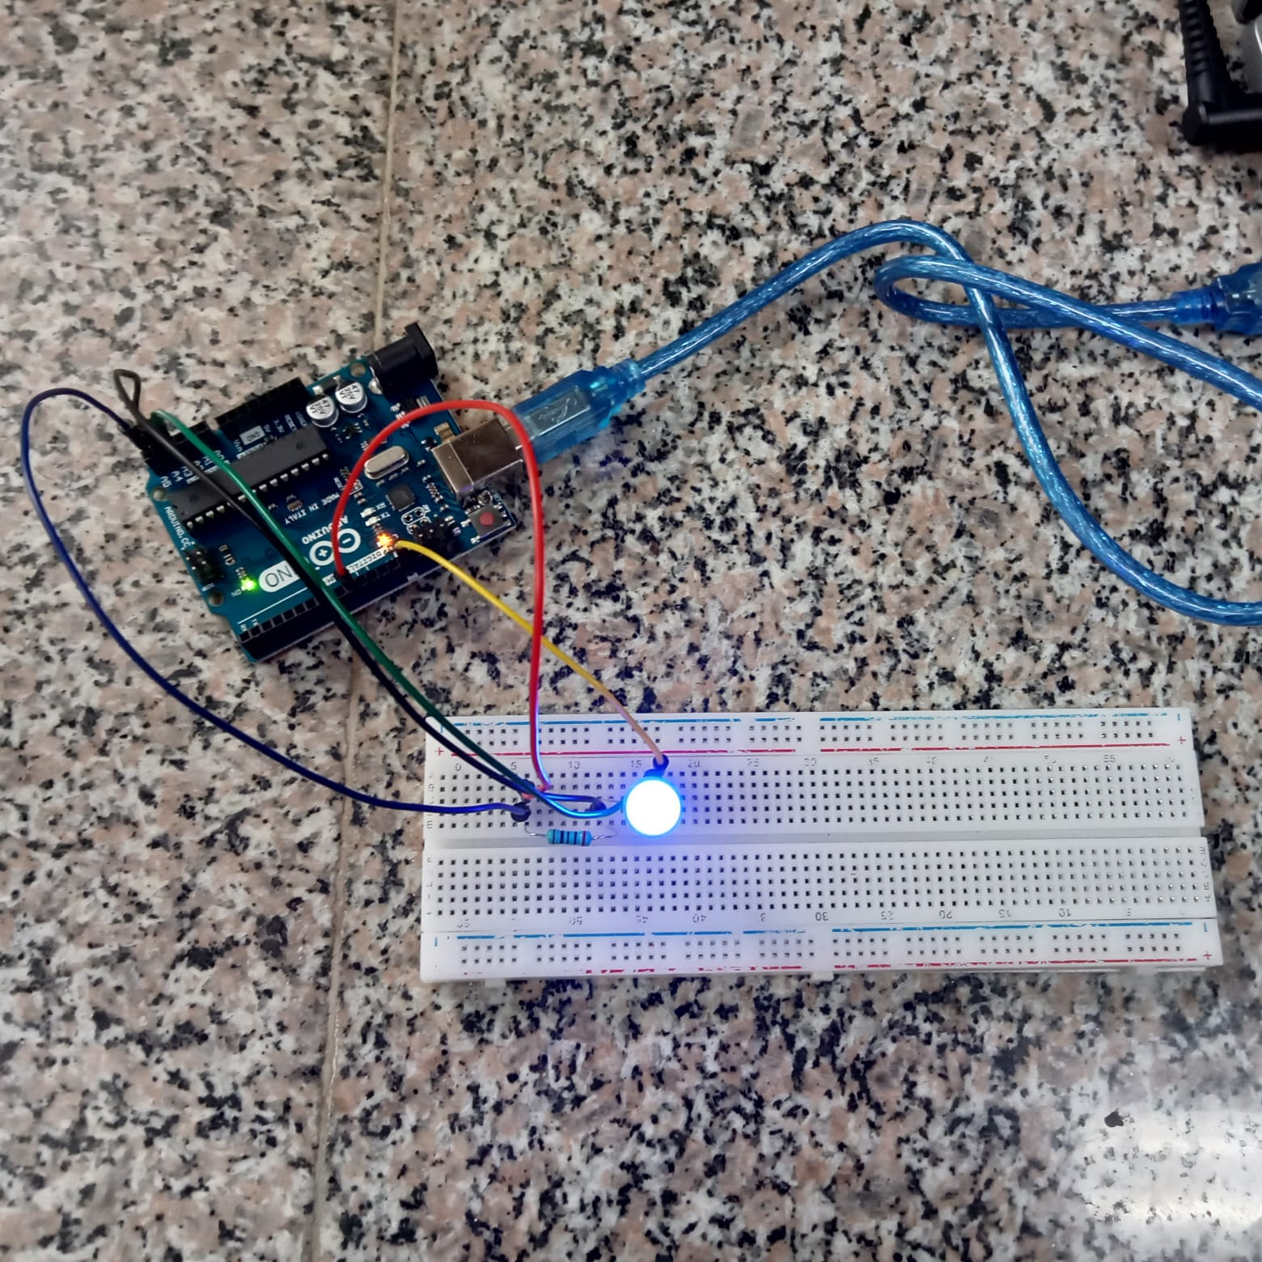
Figure 8
period | Voltage across the LED | Voltage across the resistor
10MS/10MS | 2.88 | 1.93
10MS/0MS | 2.88 | 1.93
5MS/5MS | 2.88 | 1.93
100MS/0MS | 2.88 | 1.93
100MS/100MS | 2.88 | 1.93

period | On | off | LED
10MS/10MS | 10MS | 10MS | ON
10MS/0MS | 10MS | 0MS | OFF
5MS/5MS | 5MS | 5MS | ON
100MS/0MS | 100MS | 0MS | OFF
100MS/100MS | 100MS | 100MS | ON
2S/0S | 2S | 0S | OFF
1S/1S | 1S | 1S | ON

VIDEO UPLOAD
https://drive.google.com/drive/folders/1HYlQarNsZNC85rRpcBWeWMEWm0A8Zd2I

REFERENCES
Direct current—Energy Education. (n.d.). Retrieved February 27, 2022, from https://energyeducation.ca/encyclopedia/Direct_current
Lab_and_Projects—Google Drive. (n.d.). Retrieved February 27, 2022, from https://drive.google.com/drive/folders/1RwguM6DRDUr16fuQBYnXjinGfhAa8IkJ

